*Florida International University*

*School of Computing and Information Sciences*

Software Engineering Focus

Feature Document

User Story #120

Set Up the Localhost Server

**Name:** Nathally Perez

**Team Member(s):** Mariana Sebastian

**Project:** Driverless-Car-Website-1.0

**Product Owner(s)**: Kianoosh Gholami

**Mentor(s)**: Mohsen Taheri

**Instructor**: Masoud Sadjadi

**Set up the localhost server:**

* As a developer, I would like to be able to run on the [http://localhost:3000](http://localhost:3000/) server, so that I can run my website.

Acceptance Criteria

* Start server Ability to access web page through the localhost

**Use Case**

* Name: Set up localhost server
* Actor: developer
* Preconditions:

1. Developer have access to the internet
2. Server is running on port 3000

* Description <Flow of events>:

1. Go to browser
2. Enter [http://localhost:3000](http://localhost:3000/)
3. Get request to server
4. Get response back

**Use Case Diagram**

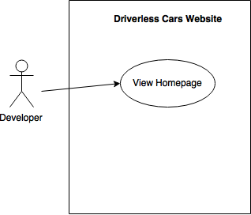

**Sequence Diagram**

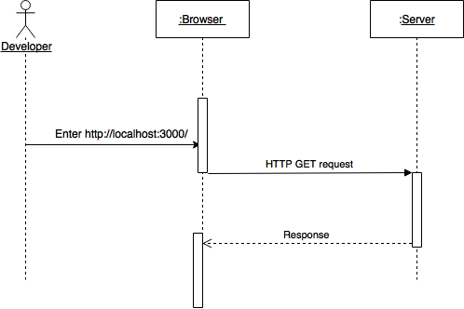

**Class Diagram**

N/A

**Unit Test:**

**Test case 1(Sunny Day)**

* Test case ID: DCW-120-01
* Description/Summary of Test: Ensure that the server is working properly.
* Pre-condition: The server is running on the localhost port 3000.
* Expected Results: Developer is able to access the localhost on port 3000 successfully.
* Actual Result: Developer was able to access the localhost successfully.
* Status (Fail/Pass): PASSED

**Test case 2(Rainy Day)**

* Test case ID: DCW-120-02
* Description/Summary of Test: Ensure that the server is working properly.
* Pre-condition: The server is running on the localhost port 3000, but developer input port 8000.
* Expected Results: Developer is unable to access the localhost on port 3000 successfully.
* Actual Result: Developer was not able to access the localhost successfully due to incorrect port number.
* Status (Fail/Pass): FAILED

**Integration Test**

The integration test was made using postman and I tested that the [http://localhost:3000](http://localhost:3000/) did not have bugs and that it was functioning correctly. The result were positive.

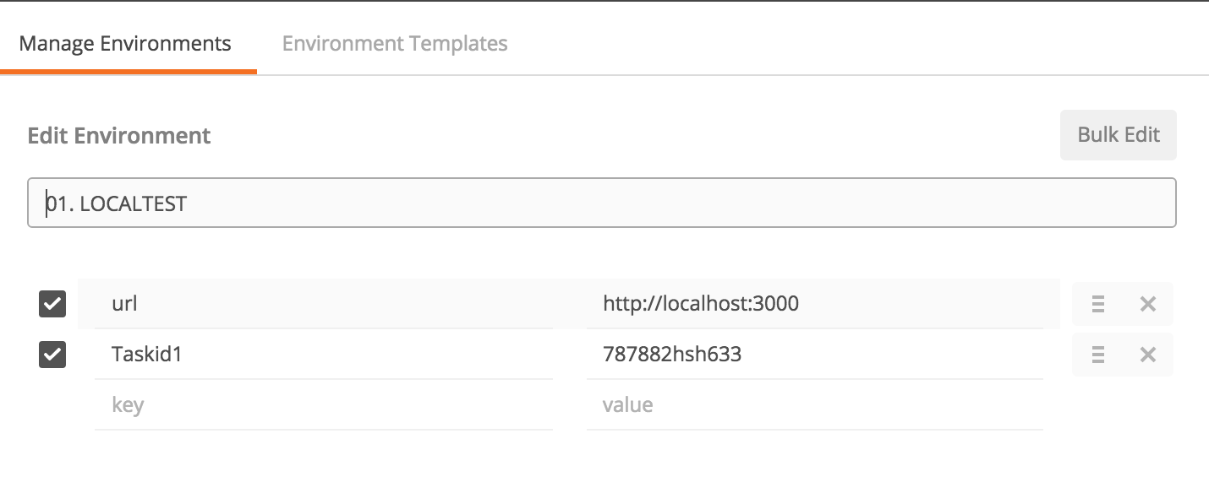

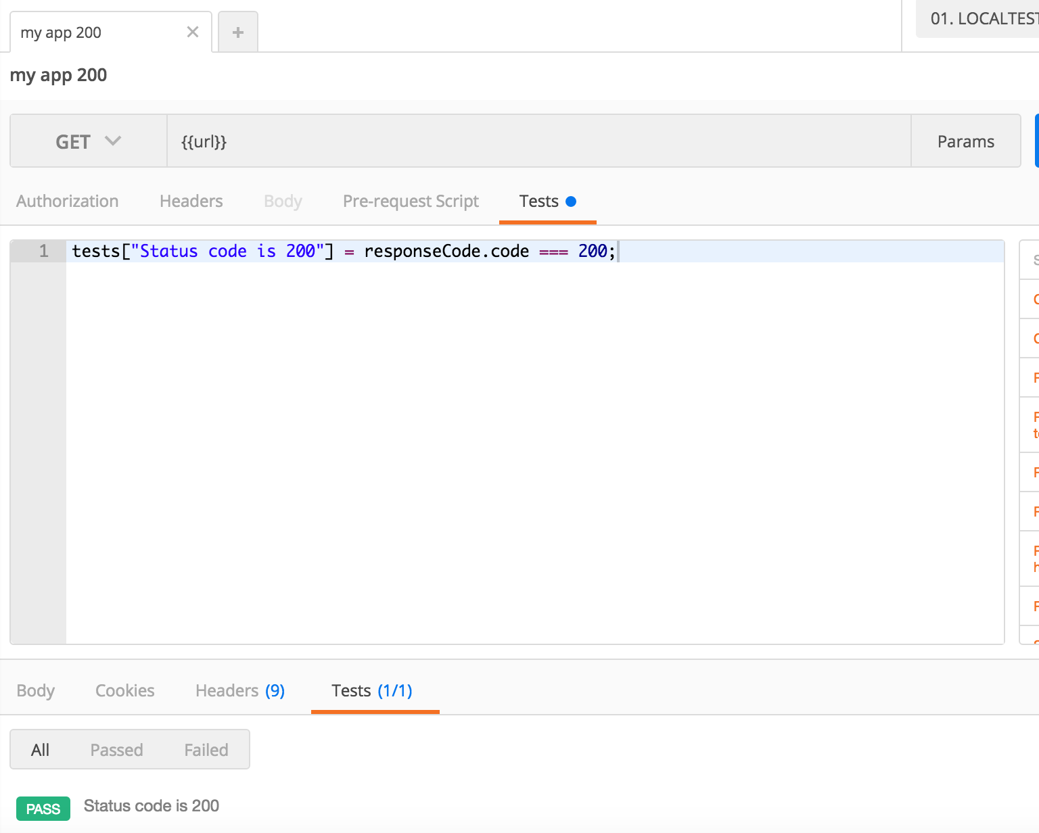

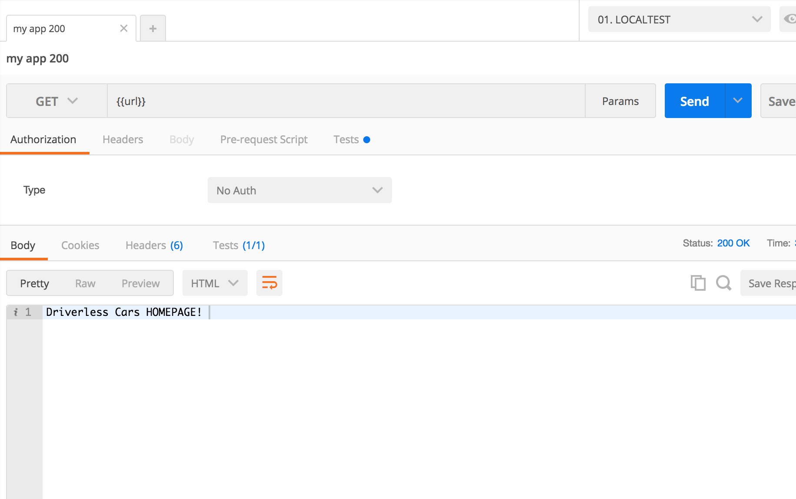

**Visual User Guide**

**Step1:** Developer starts server on localhost:3000.

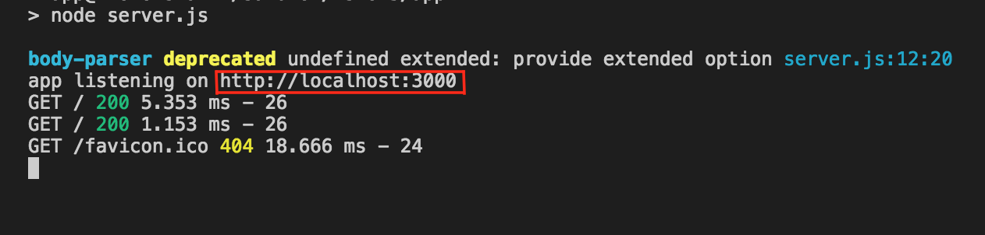

**Step1:** Developer browses localhost:3000 and gets response back.

